EMAIL MANAGEMENT SYSTEM

**Actors & Roles**

**USER**

* Sigup
* Login (Token Base JWT)
* Secondary Users – with Roles
* Emails Sending & Receiving.
* Account Details (Payment & Billing)

**Admin**

* Emails Listing
* Secodary Users Listing
* Registered User Listing
* Cron Jobs

**Functional Requirments**

|  |  |  |
| --- | --- | --- |
| **Use Case ID:** | **FR-001** | |
| **Use Case Name:** | Signup | |
| **Actors:** | | Merchant |
| **Description:** | | This use case will define the requirements and procedure for the user to register into the system. The need for this use case is for authentication purposes the user has to be registered first in order to use the Email Management System. |
| **Trigger:** | | User have to give information in Jsons Format. |
| **Preconditions:** | | The client has to enter his email, name and password and image (in base64 formet)in order to register. |
| **Normal Flow:** | | For Signup user have to hit the Signup Api on the Postman with POST method. |
| **Exceptions:** | | All the Fields is Required. If any of them is empty. Or provide the wrong information. It will generate error. |
| **Assumptions:** | | If the all the requirements are fill and correct. The client should successfully register to the system. |

|  |  |  |
| --- | --- | --- |
| **Use Case ID:** | **FR-002** | |
| **Use Case Name:** | Login | |
| **Actors:** | | Merchant & Secondary Users |
| **Description:** | | Once the user successfully registered then the user can able to login into the system. By filling the requirments into the required fields. The credentials should be match to the registered one. Once the user login in the system he will recive the token generated by JWT. |
| **Trigger:** | | User have to give information in Jsons Format. |
| **Preconditions:** | | The client has to enter his email and password in order to register. |
| **Normal Flow:** | | For Login user have to hit the Login Api on the Postman with POST method. |
| **Exceptions:** | | All the Fields is Required. If any of them is empty. Or provide the wrong information. It will generate error. |
| **Assumptions:** | | If the all the requirements are fill and correct. The client should successfully login into the system. And receive a Jwt Token. |

|  |  |
| --- | --- |
| **Use Case ID:** | **FR-003** |
| **Use Case Name:** | Listing Requests |
| **Actors:** | Merchant & Secondary Users |
| **Description:** | If user if loged in and have set the token in header so merchant can fetch the total emails sent by the merchant. And can also see the listing of secondary users. While Admin can fetch all the records of each listing. |
| **Trigger:** | User just have to hit the API with GET method. |
| **Preconditions:** | The client has to be logged in and should include the token in header |
| **Assumptions:** | It should show the correct information that is available in database. |

|  |  |  |
| --- | --- | --- |
| **Use Case ID:** | **FR-004** | |
| **Use Case Name:** | User Information/Profile | |
| **Actors:** | | Merchant & Secondary Users |
| **Description:** | | Once the user successfully registered then the user can able to login into the system. The client has to be logged in and should include the token in header |
| **Preconditions:** | | The client has to be logged in and should include the token in header. |
| **Normal Flow:** | | For Login user have to hit the User_info Api on the Postman with GET method. |
| **Exceptions:** | | GET method is Required if token is expired or have POST method it will show the error |
| **Assumptions:** | | If the all the requirements are correct. The client should successfully Able to see the Information of User. |

|  |  |  |  |
| --- | --- | --- | --- |
| **Use Case ID:** | | **FR-005** | |
| **Use Case Name:** | | Billing info & Payments | |
| **Actors:** | Merchant | | |
| **Description:** | | | Payment method is Stripe. Merchant uses the stripe account for payment and billing purpose. Where the Secondary user will uses the balance or billing of its Merchant. |
| **Trigger:** | | | User have to give information in x-Form Format. |
| **Preconditions:** | | | The client has to enter his number, ExpMonth , CVC , and ExpYear in Request panel. |
| **Normal Flow:** | | | user have to hit the Stripe Api on the Postman with POST method. |
| **Exceptions:** | | | All the Fields is Required. If any of them is empty. Or provide the wrong information. It will generate error. |
| **Assumptions:** | | | If the all the requirements are fill and correct. The client should successfully charge with the credit that has entered. |

|  |  |  |
| --- | --- | --- |
| **Use Case ID:** | **FR-006** | |
| **Use Case Name:** | Add New Secondary Users | |
| **Actors:** | | Merchant |
| **Description:** | | Merchant can add new Secondary users with different roles and permissions. |
| **Trigger:** | | User have to give information in JSONS Format. |
| **Preconditions:** | | The client has to enter his name, email ,password , View_emails, view_billing and Send_Email in Request panel. |
| **Normal Flow:** | | user have to hit the user Api on the Postman with POST method. |
| **Exceptions:** | | All the Fields is Required. If any of them is empty. Or provide the wrong information. It will generate error. |

|  |  |  |
| --- | --- | --- |
| **Use Case ID:** | **FR-007** | |
| **Use Case Name:** | Send Email | |
| **Actors:** | | Merchant & Secondary Users |
| **Description:** | | Email is sending if user have credit. Email is sendin by using PHP mailer Library. |
| **Trigger:** | | User have to give information in JSONS Format. |
| **Preconditions:** | | User have to register them self with the orignal Gmail Credentials to sent the mail. The client has to enter his to, from ,cc ,bcc, Subject , Body in Request panel. |
| **Normal Flow:** | | user have to hit the user Api on the Postman with POST method. |
| **Exceptions:** | | All the Fields is Required. If any of them is empty. Or provide the wrong information. It will generate error. Email is not Sent. |

|  |  |  |
| --- | --- | --- |
| **Use Case ID:** | **FR-008** | |
| **Use Case Name:** | Cron Jobs Sending low balance emails. | |
| **Actors:** | | Automatically |
| **Description:** | | When the low balnce api hit on the postman than the low balnce email wil sent to the users how have low balnce from 5. |
| **Normal Flow:** | | user have to hit the user Api on the Postman with POST method. |

**ERD**

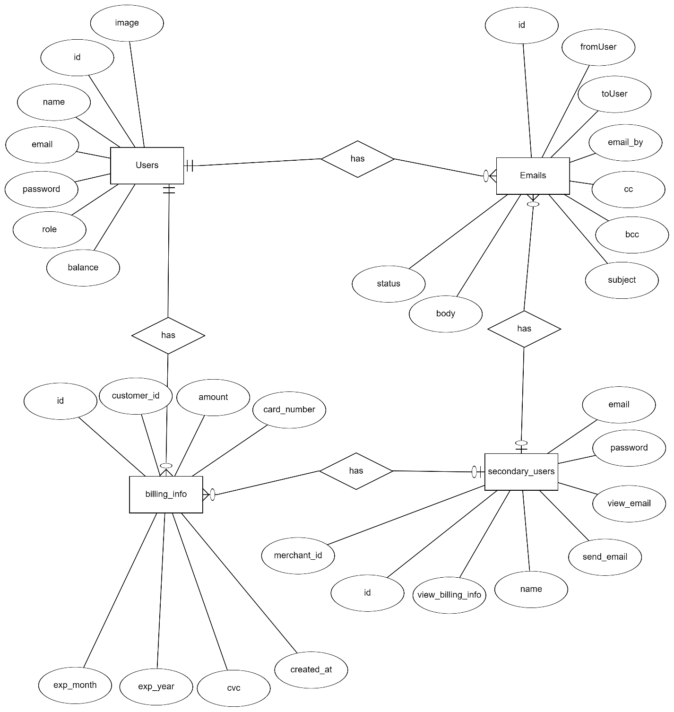

**CLASS DIAGRAM**

